**SETTING UP NETWORKING SIMULATION TOOL**

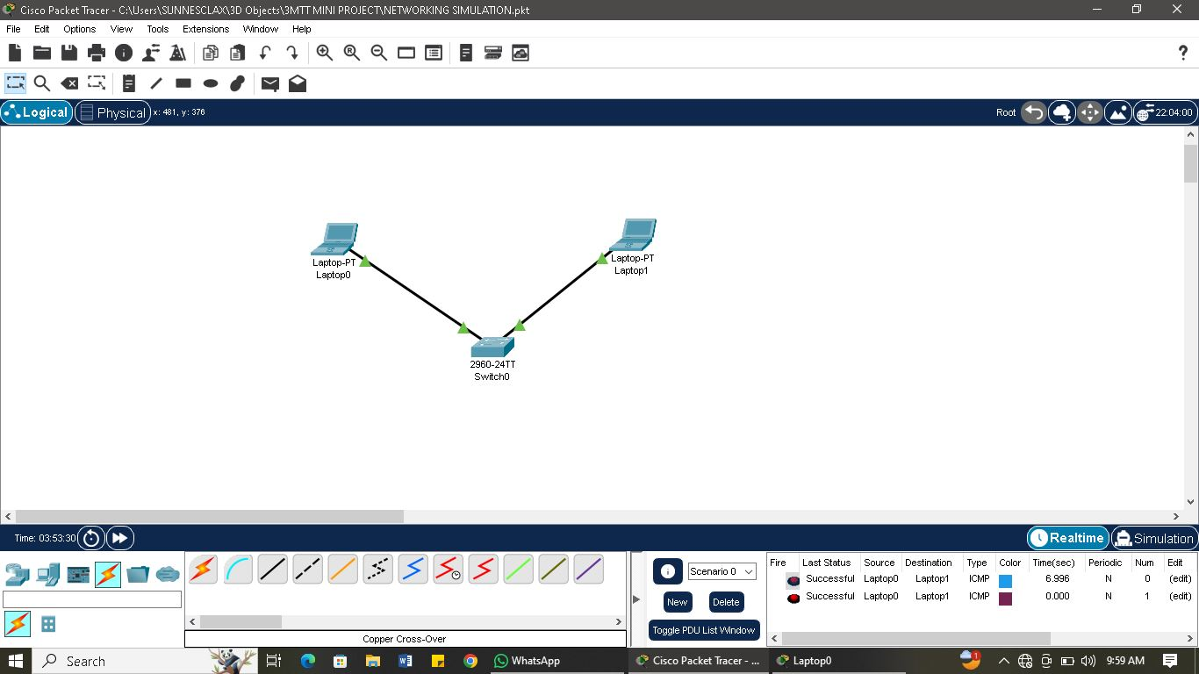

**STEPS ON SETTING UP NETWORKING SIMULATION**

**Step 1:**  after downloading cisco packet tracer, I install and launch the app from my desktop environment.

**Step 2:** firstly I played around to understand how and the functions of each tools there, so I begin by adding two laptops and one switch.

**Step 3:** I connected the two laptop using cross copper cable

**Step 4:** I assign an IP address to both laptop 1and 2 with 192.168.1.2 and 192.168.1.3 respectively.

**Step 5:** I pinged laptop 2 IP address 192.168.1.3 on laptop 1 using the desktop command prompt with give out the result below

**RESULT OF CONNECTIVITY TEST**

Cisco Packet Tracer PC Command Line 1.0

C:\>ping 192.168.1.3

Pinging 192.168.1.3 with 32 bytes of data:

Reply from 192.168.1.3: bytes=32 time<1ms TTL=128

Reply from 192.168.1.3: bytes=32 time=3ms TTL=128

Reply from 192.168.1.3: bytes=32 time=6ms TTL=128

Reply from 192.168.1.3: bytes=32 time=5ms TTL=128

Ping statistics for 192.168.1.3:

Packets: Sent = 4, Received = 4, Lost = 0 (0% loss),

Approximate round trip times in milli-seconds:

Minimum = 0ms, Maximum = 6ms, Average = 3ms